

**WORKSHEETS**

**Worksheet 2.1**

**Ideal Method**

**Make the longest word**

Make the longest word using each letter of the words.

**Example:**

**I D E A L, ACTION,**

|  |  |  |  |  |  |
| --- | --- | --- | --- | --- | --- |
| **I** | **D** | **E** | **A** | **L** | **Total letters** |
| **Insect** | **dinosaur** | **elephant** | **ant** | **lion** | **29** |

**I D E A L, ACTION,**

|  |  |  |  |  |  |
| --- | --- | --- | --- | --- | --- |
| **I** | **D** | **E** | **A** | **L** | **Total letters** |
| **Indigo** | **dark** | **elephant** | **aquamarine** | **Lila** | **32** |

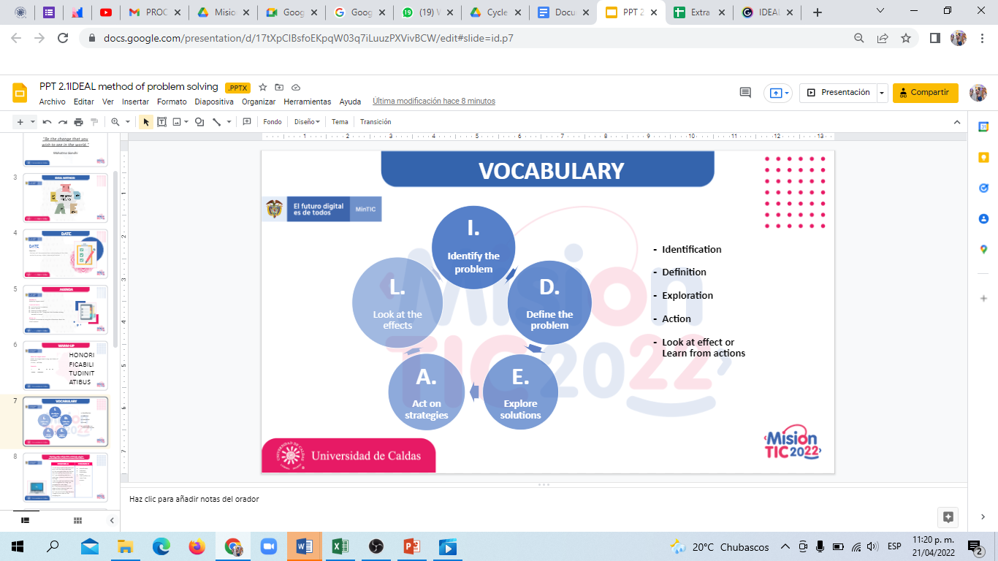

**Problem solving**

1. Match the problem with the IDEAL method order and put the correct answer in the A column.

|  |  |
| --- | --- |
| Column a | Column b |
| I want to always be prepared for taking out the trash. Definition | Identification |
| Placing an online order for bags takes too much time, but I could do it in advance.  Act | Definition (recuerden que es definition del outcome, lo que yo busco ser o lograr al final del method) |
| I use something else for a trash bag; I place an online order for bags; I take the trash out without a bag; I ask a neighbor for a bag; I go shopping for trash bags. Exploration | Exploration |
| I placed an online order for bags, but the bags take too much time to arrive to my house, I asked my neighbor and he lent me a bag.  Look nack | Act |
| I need to take out the trash tomorrow but I ran out of bags. Identification | Look back |

**Reading strategy**

<https://youtu.be/xJGQIYU_xhs>

* **Watch the video and write some important ideas.**

1. main idea is supported by supporting ideas and title
2. images give us general ideal
3. the conclusion reminds us of the main text

**WORKSHEET 2.2**

* **Read the following text: “Using the IDEAL Problem Solving Method in Groups”.**

In introductory psychology courses, the desire to cover content can conflict with the desire to acquaint students with psychological thinking processes. The IDEAL method is a group problem solving quiz technique which addresses both of these goals. In the process, instructors choose key concepts from a given reading and divide the class into groups of four to six students. Each member of each group then chooses a concept to specialize in, completing concept sheets which compare and contrast their concept to other assigned concepts. Groups then determine how to apply their understandings of their concepts to common situations, such as when an individual decides to accompany a group to an event that they do not believe will be enjoyable. Testing is conducted in essentially the same format, with quizzes evaluated on the basis of how aspects of the scenario exemplify the concept in action or how the students apply the concept to the scenario in order to address the question. The advantages of this method for psychology classes are that it makes use of student learning and gives them practice with problem solving, critical thinking, and group interaction skills while teaching the content of the subject area. A disadvantage is that the amount of material covered must be reduced to allow for time spent on problem solving techniques and teamwork skills.

**WORKSHEET 2.3**

**EVALUATION**

* **Complete the following sentences using the information about the IDEAL method.**

1. **You use the IDEAL method to __ solve problems______________________________**
2. **The first step to solve a problem is identify the problem through analysis___**
3. **Action taking is using to _ explore strategies______________________________**
4. **The IDEAL method is good because ____faster problem solving_____________**
5. **The second step to solve a problem is _____definition__________________**

**WORKSHEET 2.4**

**SELF-EVALUATION**

1. **Comprendo la importancia del uso del “IDEAL M” para resolver problemas.**

**Yes No Maybe**

1. **Entiendo los pasos a seguir para resolver un problema.**

**Yes No Maybe**

1. **Puedo usar el “IDEAL M” para resolver un problema.**

**Yes No Maybe**